Guide to assembly of the Arduino based

CG Scale for F3X gliders

(and other model airplanes) by Olav Kallhovd

This scale can be used for most modern F3F/F3B gliders with slim fuselages using the standard supports. If you have chosen to print the _big versions of the supports, you will also be able to fit many other models on the scale.

The maximum load is ~5kg.

This guide assumes that you are already familiar with loading software onto an Arduino, and that you have already done this, or at least will do it before using the scale.

## Drilling and fitting:

Before you get into soldering, you need to prepare the printed parts.

Any penetrating holes are blinded for better print quality. These have to be drilled through before assembly.

Depending on the dimensional accuracy of your 3D printer, some of the holes, including the ones to fit the nuts, may be slightly undersized. Carefully use a suitable drill-bit to enlarge the holes.

For the deep holes on the underside of the base that hold the load cell screws to the base, be careful to not drill too deep.

The load cell cover that conceals the gap in the center of the scale, likely needs some sanding on the inside to prevent it from rubbing on the wires from the load cells. This will become clear when fitting it over the load cells.

## Assembly, mechanical parts:

1. Install M3 nuts in the frame. If the holes for the nuts are too small, gently push the nuts into the holes with a hot soldering iron, and they should slide right in.
2. Attach the load cells with the text on the ends pointing outwards and right side up. The 2kg cell goes in front and the 3kg at the back. The load cell contact surfaces must be flat and true, and may need some work with a small file, or you may have to carefully remove some of the silicone.

Be VERY careful that you don’t damage the wires under the silicone.

1. Check overall alignment. Everything must be straight and true for the scale to be accurate. Use a file on the plastic parts if any adjustment is required.
2. Thread the wires from the rear load cell through the small hole under the cells so they are available on the side where you will be fitting the electronics.
3. Fit the small wing pads to the supports. The 4 wing pads are angled for wing dihedral and must be installed with correct orientation, sloping inwards slightly. For a hinge, use some thin steel pushrod. The hinges for the wing pads must be loose to avoid any binding and to give some allowance for different wing dihedrals. Use a 2mm drill bit on the hole in the wing pads if they are too tight. Secure the rods in place with a tiny dab of CA on the outside of the hole in the support and fit a small piece of soft foam or felt to each pad. Using soft material with low-friction may reduce internal binding between the pads, hence improve accuracy.
4. Scuff the ends of some 3mm steel pushrod or pianowire using coarse sandpaper or a dremel, and glue into the holes on the front support using epoxy or CA. The rods must have a tight fit so they are perfectly vertical and aligned. Ensure that they protrude enough to allow for wing profiles with a high LE.
5. Use callipers to take some accurate “As-built” measurements of the assembled unit. The dimensions “WingPegDist” and “LEstopperDist” must be included in the Arduino sketch. See figure 1 below.

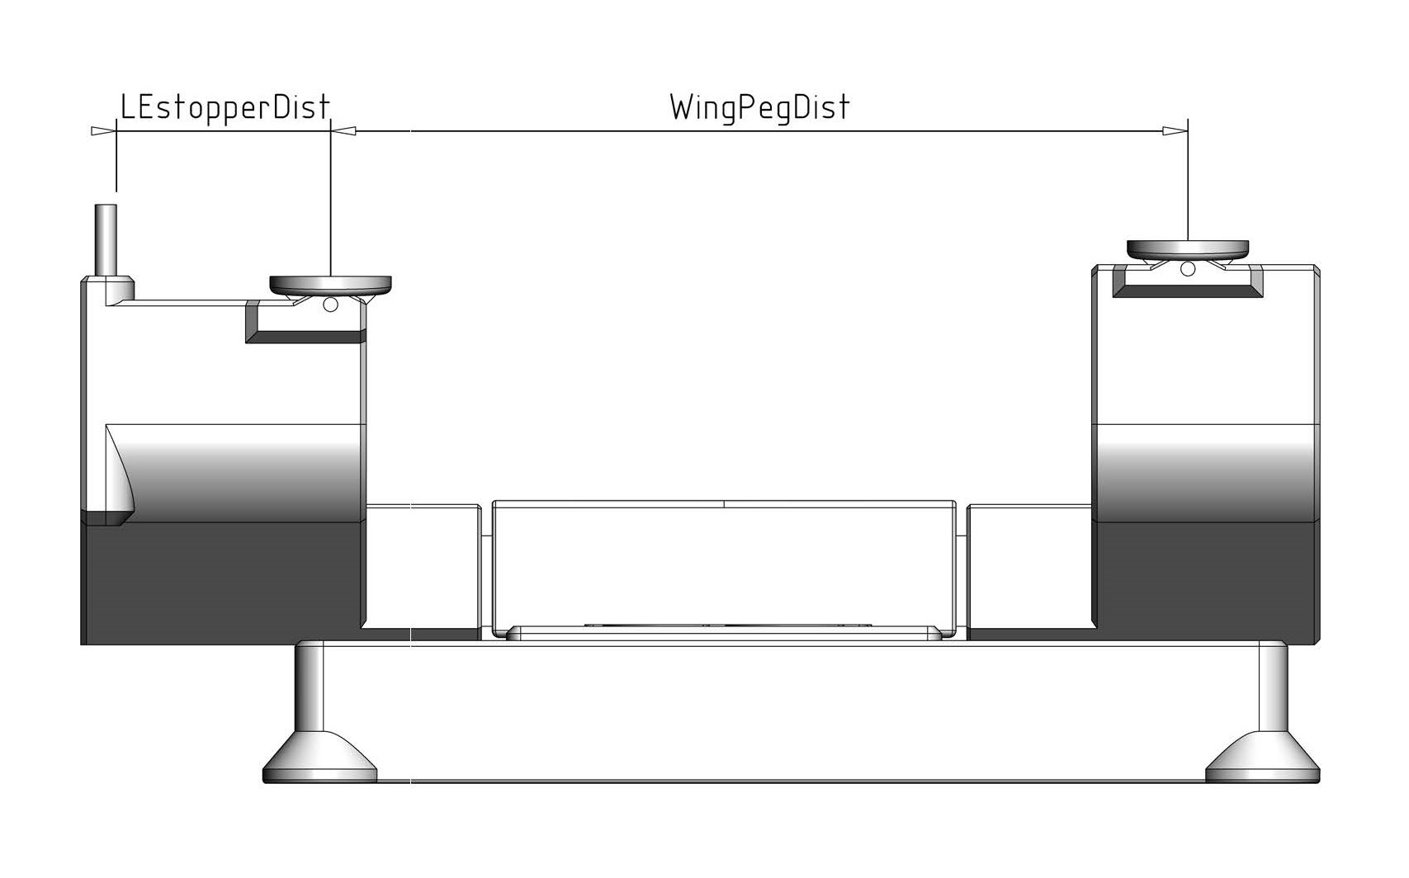

Figure 1

## Assembly, electronics:

1. Solder each of the load cells to a HX711 module. Be aware that the colours of the wires in the diagram may be different from the cells you have purchased.

To avoid shorting something within the compartment, it’s a good idea to carefully wrap the modules in heat shrink or kapton tape after soldering.

1. Solder the remaining components according to the diagram. Take note of any wires that need to be threaded through a hole before soldering them. This includes wires for the switch, battery and display.
2. I2C Display:

If you are using an LCD display with I2C backpack, ignore the LCD diagram “Circuit_Serial_LCD” and instead:

* Connect Display GND to any Arduino-GND that is free
* Connect Display VCC to Arduino VCC
* Connect Display SDA to Arduino A4
* Connect Display SCL to Arduino A5

1. Serial Display:

If you are using an LCD display with an Arduino Mini backpack for serial communication, connect parts according the LCD diagram “Circuit_Serial_LCD” and upload sketch *SimpleSerialDisplay.ino* to the Arduino Mini.

The LED light is optional.

The Zero-Button is optional.

Instead of using a 9V battery as suggested in the diagram, you can choose to fit a JST connector outside the base and use a 2S Lipo battery. Your power source simply needs to supply at least 6V and no more than 12V.

## Software:

If you haven’t already done so, this would be a good time to upload the software. Download and install the Arduino IDE on your PC. Copy the Github *CG_scale* folder to the Arduino Sketch folder on your PC. If you use an Arduino without USB, like the Arduino Mini you need an USB to TTL programming adapter for interfacing.

Check the configuration settings in the file config.h and do changes if needed. Now, upload the sketch *CG_scale.ino* onto the Arduino controller.

If you are using a Serial display rather than an I2C display, you must also upload the sketch *SimpleSerialDisplay.ino* onto the Arduino controller for the display.

## First use/calibrating:

1. Connect USB and open the Arduino IDE Serial Monitor. The “Serial menu” will appear.
2. Connect the battery (the voltage may affect calibration of the loadcells).
3. Now, calibrate loadcell Front, loadcell Rear and battery voltage by following the instructions. When asked to save calibration values to EEPROM, send ‘y’.

## Using the CG Scale:

1. Turn the scale on without any model on the supports.
2. Wait for the initialization to complete before placing a model on it.

This allows for the scale to set itself to 0g.

1. Place the model on the supports.
2. Ensure that the leading edge of the wings are touching the stops on both sides.
3. The display will show the total weight of the model and the Center of Gravity.
4. Using your fingertips under the wing you can lift and reposition the model on the scale a few times to ensure a consistent measurement and that there is no binding forces between the supports.

Additional notes: The model is measured with a slight "nose down" angle. This is intentional and is not adjustable, but it is possible to change the angle by modifying the front or the rear support height. If properly built, the scale is as accurate as you can place the model on it. Try to relocate the model a few times to verify that the measured CG value is repeatable.